**Visualizing Housing Market Trends: An Analysis of Sale Prices and Features using Tableau**

**Introduction:**

In this project for ABC Company, the goal is to address challenges in understanding the factors that influence house prices and sales trends. By analysing comprehensive housing data, including the total sales by years since renovation, house age distribution by the number of bathrooms, bedrooms, and floors, and the impact of renovations on house age, the company aims to uncover key insights. Utilizing Tableau for this analysis, the objective is to visualize and interpret patterns in the housing market to inform strategic decisions, optimize pricing strategies, and enhance overall market competitiveness. Key stakeholders include real estate analysts, marketing teams, and company executives, all of whom will benefit from a deeper understanding of housing market dynamics.

**Scenario 1: Overall Data Overview**

This visualization presents a summary of the dataset, showing the count of transformed housing data records, the average sales price, and the total area of houses from the basement in square feet. This overview provides a quick snapshot of the dataset's scale and key metrics, offering stakeholders a foundational understanding of the data being analyzed.

**Scenario 2: Total Sales by Years Since Renovation**

This histogram illustrates the distribution of total sales based on the number of years since a house was renovated. The bars represent different sales price bins, highlighting how recently renovated houses correlate with varying price ranges. This scenario helps stakeholders understand the impact of renovations on house prices and identify trends in buyer preferences regarding renovated homes.

**Scenario 3:** **Distribution of House Age by Renovation Status**

This pie chart shows the distribution of houses based on their age and renovation status. Each segment of the pie represents a different age group, providing insight into how the age of houses is spread across the dataset and the proportion of houses that have been renovated versus those that have not. This visualization assists in assessing the age characteristics of the housing inventory and the prevalence of renovations.

**Scenario 4: House Age Distribution by Number of Bathrooms, Bedrooms, and Floors**

This grouped bar chart displays the distribution of house ages categorized by the number of bathrooms, bedrooms, and floors. It shows how houses of different ages are distributed according to these attributes, offering a detailed view of how house features vary with age. This scenario helps stakeholders identify patterns in housing characteristics and preferences related to house features over time.

**Technical Architecture:**

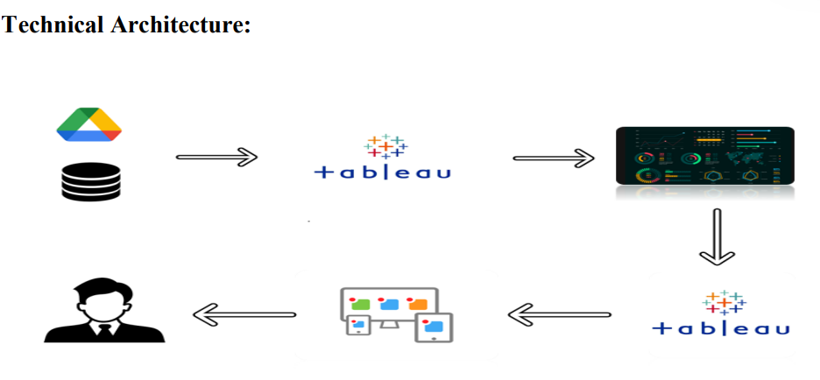

**Project Flow**

To accomplish this, we have to complete all the activities listed below,

* Data Collection
  + Collect the dataset,
  + Connect Data with Tableau
* Data Preparation
  + Prepare the Data for Visualization
* Data Visualizations
  + Visualizations
* Dashboard
  + Responsive and Design of Dashboard
* Storyboard
* Storyboard Creation
* Performance Testing
  + Utilization of Data Filters
  + No. of Calculation fields
  + No. of Visualizations/Graphs
* Project Demonstration & Documentation
  + Record explanation Video for project end to end solution
  + Project Documentation-Step by step project development procedure

**Milestone 1: Data Collection & Extraction from Database**

Data collection is the process of gathering and measuring information on variables of interest, in an established systematic fashion that enables one to answer stated research questions, test hypotheses, evaluate outcomes and generate insights from the data.

**Activity 1: Downloading the dataset**

Please use the link to download the dataset: [Link](https://www.kaggle.com/datasets/rituparnaghosh18/transformed-housing-data-2)

**Activity 1.1: Understand the data**

Data contains all the meta information regarding the columns described in the CSV files

**Column Description of the Dataset:**

1. Overall Data Overview
2. Total Sales by Years Since Renovation
3. Distribution of House Age by Renovation Status
4. House Age Distribution by Number of Bathrooms, Bedrooms, and Floors

**Milestone 2: Data Preparation**

Preparing the data for visualization involves cleaning the data to remove irrelevant or missing data, transforming the data into a format that can be easily visualized, exploring the data to identify patterns and trends, filtering the data to focus on specific subsets of data, preparing the data for visualization software, and ensuring the data is accurate and complete.

**Activity 1: Prepare the Data for Visualization**

This process helps to make the data easily understandable and ready for creating visualizations to gain insights into the performance and efficiency. Since the data is already cleaned, we can move to visualization.

3.1: Data Loading

<https://drive.google.com/file/d/1wam7sT7_CHfjx9x2ZVUbeMa6DJqK_AeN/view?usp=sharing>

3.2 Data Cleaning

<https://drive.google.com/file/d/1g_Ye0tpPWpRlEl4FHL8F03mckLO3uGN7/view?usp=sharing>

**Milestone 3: Data Visualization**

Data visualization is the process of creating graphical representations of data to help people understand and explore the information. The goal of data visualization is to make complex data sets more accessible, intuitive, and easier to interpret. By using visual elements such as charts, graphs, and maps, data visualizations can help people quickly identify patterns, trends, and outliers in the data.

**Activity 1: Visualizations**

**Activity 1.1: Count of Transformed_Housing_Data**

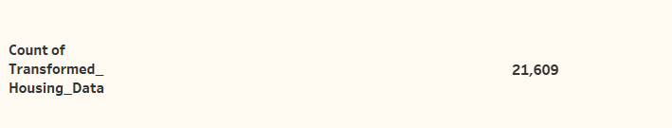

**Activity 1.2: Average Sale Prices**

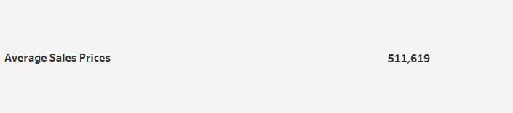

**Activity 1.3:** **Area of House from Basement(in Sqft)**

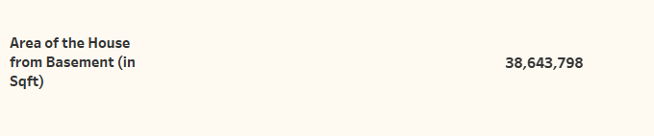

**Activity 1.4** **Total Sales by Years Since Renovation**

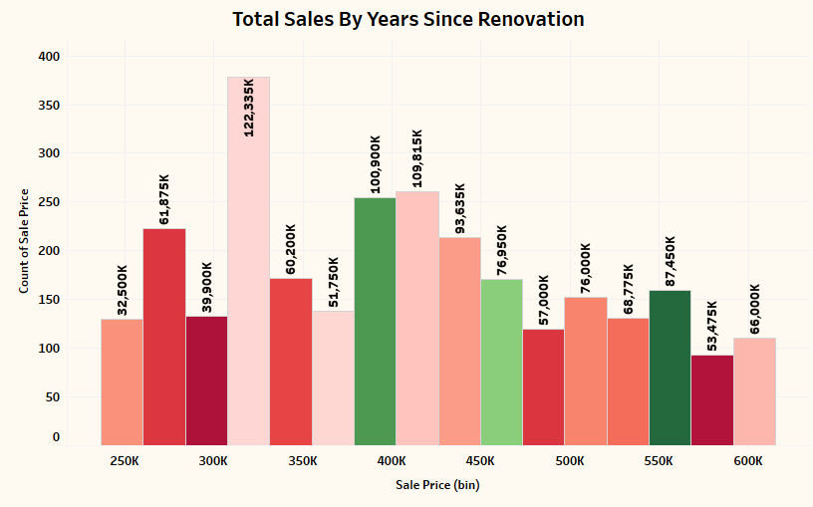

**Activity 1.5** **Distribution of House Age by Renovation Status**

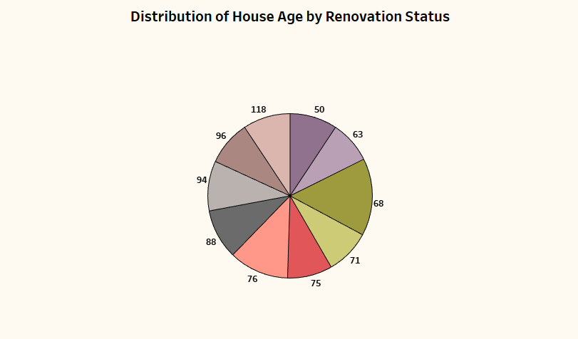

**Activity 1.6** **House Age Distribution by Number of Bathrooms, Bedrooms, and Floors**

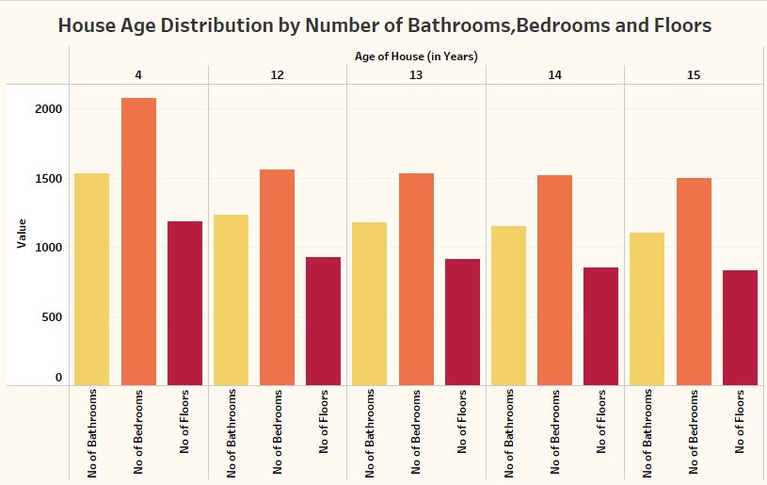

**NOTE:** Video Explanations for the above Visualizations are in Dashboard and Report sections.

**Milestone 4: Dashboard**

A dashboard is a graphical user interface (GUI) that displays information and data in an organized, easy-to-read format. Dashboards are often used to provide real-time monitoring and analysis of data and are typically designed for a specific purpose or use case. Dashboards can be used in a variety of settings, such as business, finance, manufacturing, healthcare, and many other industries. They can be used to track key performance indicators (KPIs), monitor performance metrics, and display data in the form of charts, graphs, and tables.

**Activity 1- Responsive and Design of Dashboard**

**Explanation video link:**

<https://drive.google.com/file/d/1D48J0AThkiBw9BwwOreCiyBdlAvp2Qja/view?usp=sharing>

**Dashboard:**

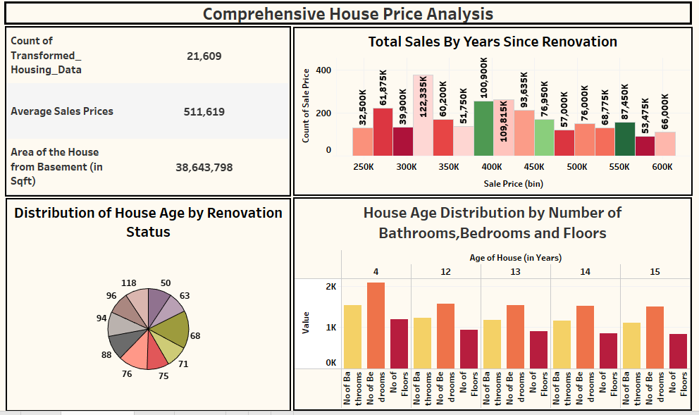

**Milestone 5: Storyboard**

A storyboard is a visual representation of a sequence of events, typically used in multimedia projects such as films, animations, advertisements, or presentations. It consists of a series of drawings or images arranged in a sequence, often accompanied by annotations or descriptions, to outline the flow of the story or concept.

**Activity 1: Design of Storyboard**

To design a storyboard in Tableau, start by defining the key elements and flow of your narrative. Utilize Tableau Analytics' capabilities to create a series of interactive visualizations, such as charts, graphs, and KPI cards, that represent each scene or stage of your story. Arrange these visualizations sequentially on a dashboard, ensuring a logical progression from beginning to end. Incorporate text boxes, annotations, and navigation buttons to provide context, explanation, and interactivity within the storyboard. Customize the design and layout to enhance clarity and engagement, leveraging Tableau' formatting options and templates.

**Explanation video link:**

<https://drive.google.com/file/d/1nIyItMopZbD3nFYmGvRiSgElvhytTDs6/view?usp=sharing>

**Storyboard:**

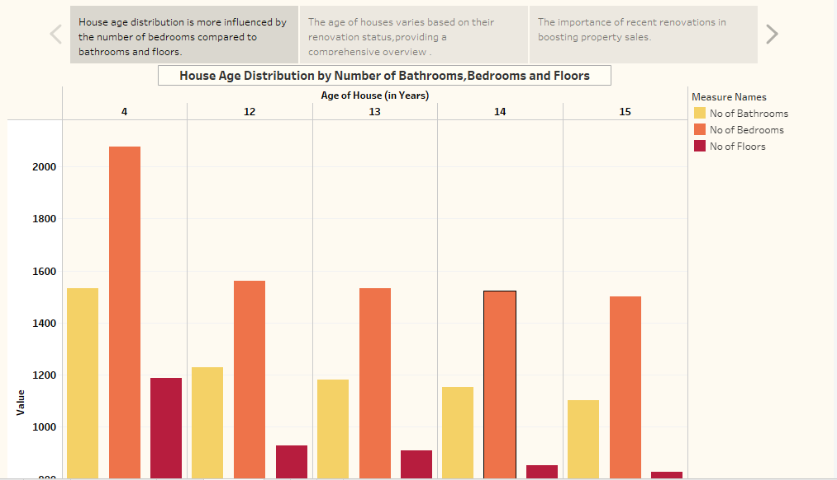

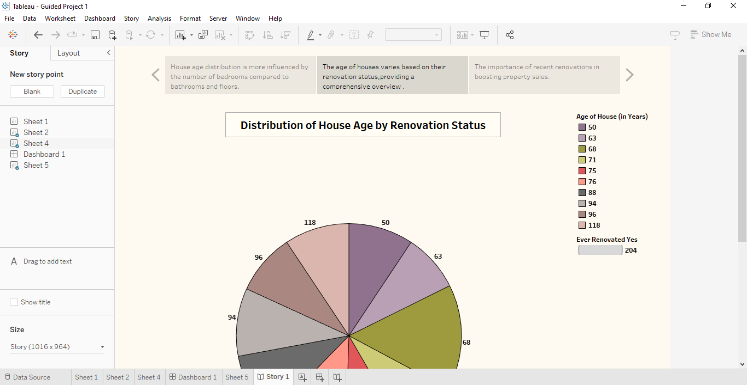

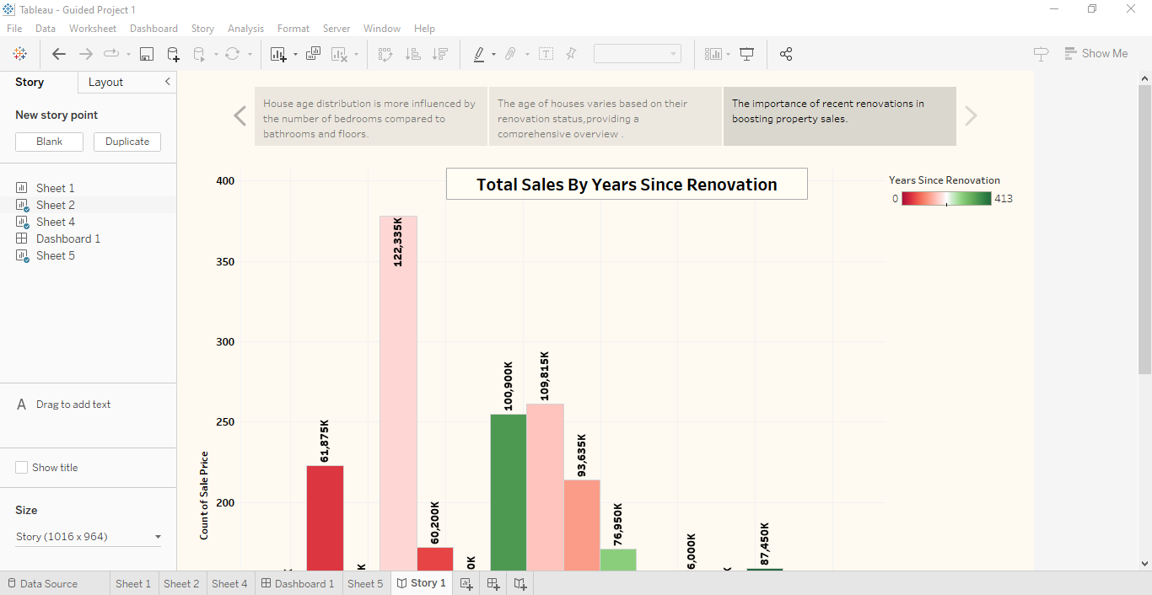

**Milestone 6: Project Demonstration & Documentation**

Below mentioned deliverables to be submitted along with other deliverables

**Activity 1: - Record explanation Video for the project's end-to-end solution**

Creating a record explanation video for a project's end-to-end solution is crucial for ensuring clarity and transparency in its implementation.

**Activity 2: - Project Documentation-Step by step project development procedure**

Create document as per the template provided